**UD Financials Job Aid**

**Research Admin: Homepage Navigation**

**Overview: This job aid will:**

* **provide an introduction to a Homepage in UD Financials;**
* **describe how to navigate to the Research Ofc Homeage and**
* **give instructions for making the Research Ofc Homepage the default**

The screenshot below outlines many of the features and links found on the UD Financials Homepage

1

2

3

4

5

6

7

8

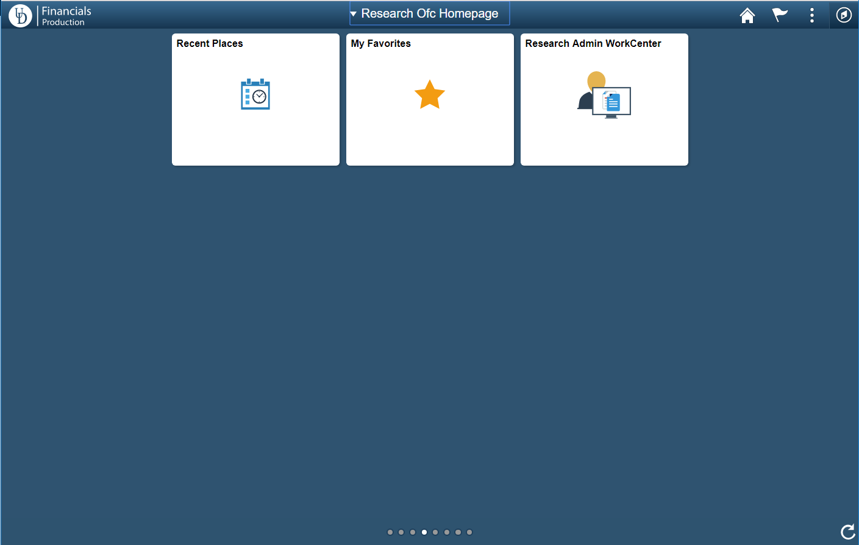

**Navigation Icons**

* Clockwise from top center:
  1. Homepage drop-down selection. Use to switch between any homepages to which you have access.
  2. Home button. Click this from any screen to return to your homepage.
  3. Notifications. UD is not implementing any Notifications functionality at go-live.
  4. The Actions List or “hamburger.” Press the Actions List button to reveal actions you can make based on your location in the application, and to Sign Out.
  5. NavBar (looks like a compass). Click this to access the Navigator which will take you to the menu you already know from PeopleSoft version 9.1.
  6. Refresh button. Refreshes all tiles on homepage.
  7. Homepage indicator. just shows the total number of available homepages, represented by a small circle.
  8. Tiles. Icons to navigate to specific, frequently-used menu items.

**Navigating to the Research Office Homepage**

**Step One**

* From the landing page, click on the Homepage drop-down selection item

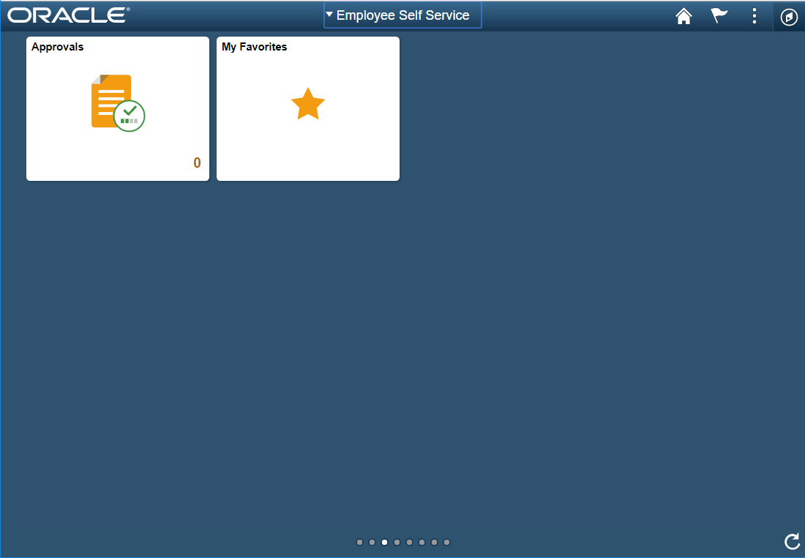

* Select Research Ofc Homepage from the list

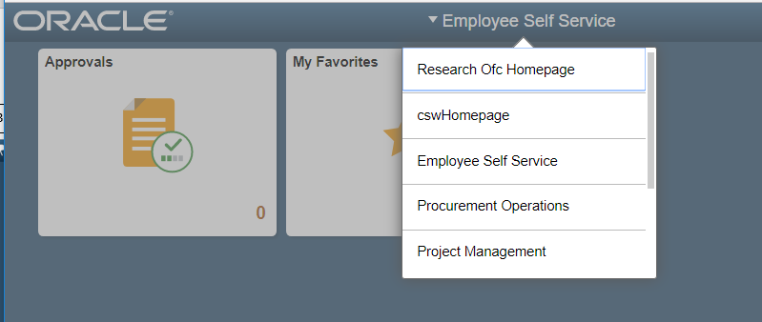

**Make the Research Office Homepage My Default**

**Step One**

* From the landing page, click on the Actions List icon

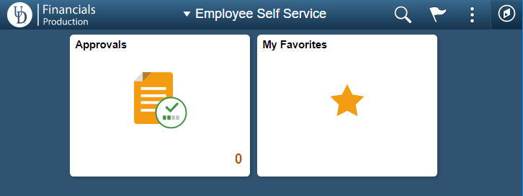

* Select Personalize Homepage

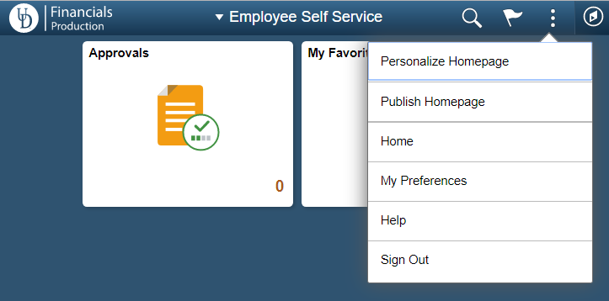

* From the Personalize Homepage page, click on the “Research Ofc Homepage” icon and drag it to the top of the list.

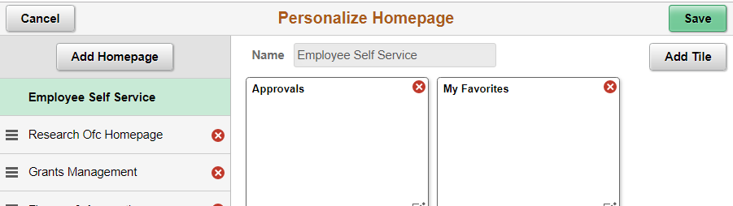

* Release the icon when it is at the top of the list.

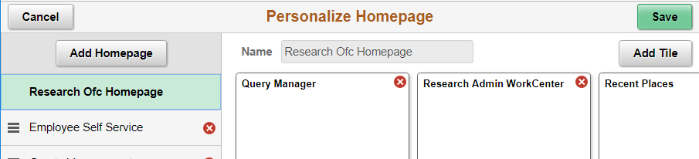

* Click the Save button

