University of Delaware Office of Laboratory Animal Medicine

CAPTIVE BOLT DEVICE PROTOCOL FOR USE WITH AGRICULTURAL ANIMALS SOP PRO-020

Dr. Annie Renzetti

Regarding Large Animals (Equine, Bovine, Porcine, Ovine, Caprine, Camelid)

1. Indications for Euthanasia - when disease or injury conditions arise that diminish quality of life or create pain and suffering that cannot be effectively relieved by medical means, euthanasia is indicated.
Examples include the following:
- Fractures of the legs, hip or spine that are not repairable and result in immobility or inability to stand
- Emergency medical conditions that result in excruciating pain that cannot be relieved by treatment (e.g. terminal colic in horses, or trauma associated with highway accidents
- Emaciation and/or debilitation from disease or injury that may result in an animal being too weak to be transported
- Paralysis from traumatic injuries or disease that result in immobility
- Advanced eye disease (e.g. lymphoma or cancer eye in cattle)
- Disease conditions for which cost of treatment is prohibitive
- Disease conditions where no effective treatment is known (Johne's Disease in ruminants), prognosis is poor or time to expected recovery is unusually prolonged
The loss of productive function as a result of disease or injury in livestock presents at least two options: slaughter or euthanasia. Generally speaking, slaughter should be considered for animals that are not in severe pain, freely able to stand and walk, capable of being transported, and without disease or treatment that might constitute a public health risk (drug residue). Euthanasia is the appropriate choice whenever the above conditions cannot be met. Euthanasia may also be indicated if it is part of a research protocol that has been approved by the IACUC.

When conditions warrant euthanasia, the next consideration is method. There are essentially 2 methods for humane euthanasia in circumstances where veterinary supervision is unavailable:
- Device shot with the appropriate caliber of firearm and a solid point bullet delivered to the correct anatomical site (not applicable at the University of Delaware).
- Penetrating captive bolt to induce immediate loss of consciousness followed by the use of a pithing device to ensure death.

Choices of one over the other should include concerns for human safety, animal welfare, ability to restrain the animal for proper application of the procedure, skill of the person performing the procedure, cost, rendering and carcass disposal considerations, and possibly, potential need for brain tissue (for diagnostic purposes) in the event that the animal is suspected of having rabies.
Persons conducting euthanasia procedures should attempt to minimize animal distress. If animals are accustomed to human contact the presence of a familiar person may be reassuring and reduce anxiety. On the other hand, for wildlife and animals unaccustomed to human contact, euthanasia should be accomplished with the least amount of human contact necessary. If the animal to be euthanized is ambulatory and able to be moved without causing distress, discomfort or pain, it may be moved to an area where the carcass may be more easily reached by removal equipment. Dragging of non-ambulatory animals is unacceptable. In cases where movement may increase distress or animal suffering, the animal should be euthanized first, and moved following confirmation of death.

2. Notification to University of Delaware Public Safety
Prior to any use of the captive bolt device for any reason, the University of Delaware Department of Public Safety must be notified. This disclosure should occur as far in advance of the discharge of the device as possible. This notification is to prevent to mistaken reporting of gunshots by someone overhearing the sound of the device. (302-831-2222)

3. Penetrating Captive Bolt
The mode of action of a penetrating captive bolt device is concussion and trauma to the brain. This requires that it be held firmly against the surface of the head over the intended site. This constitutes a major difference between the placement of a firearm and the placement of a penetrating captive bolt. Because placement and positioning of the projectile is critical, some degree of restraint is required for proper use of this device. A rope halter is sufficient to restrain the head for ensuring proper placement of the penetrating captive bolt.
The penetrating captive bolt is discharged by gunpowder. It works by concussion and trauma to the brain. It causes immediate unconsciousness and destruction of brain tissue as a result of penetration of the discharged bolt. While the destruction of brain tissue with the penetrating captive bolt may be sufficient to result in death, operators are required to ensure death by pithing.
The captive bolt device owned by the University of Delaware is Jarvis model number: 4144132

4. Poor Performance
The most common reasons for poor performance of penetrating captive bolt devices include:
- Failure to service and clean the device after use
- Failure to properly store cartridge charges in a cool and dry location
- Failure to replace damaged parts as needed
- Inadequate training of personnel

5. Anatomical Landmarks for Captive Bolt Device Application by species
Proper positioning of the firearm or penetrating captive bolt is necessary to achieve the desired results.

Cattle
In cattle, the point of entry of the projectile should be at the intersection of two lines each drawn from the rear corner (outside corner) of the eye to the base of the opposite horn. Not between the eyes!
Goats and Sheep
Penetrating captive bolt or gunshot followed by immediate exsanguination are the preferred methods of euthanasia in sheep. For hornless sheep, goats and rams the recommended sites for placement of the device or penetrating captive bolt include the top of the head or slightly behind the poll. Sheep should be pithed within 10 seconds after stunning by penetrating captive bolt or they may regain consciousness.
In horned sheep and rams the top of the head may not be the ideal location because of the thickness of the skull in this region. Instead, an alternate position and orientation for penetrating captive bolt or gunshot in horned animals is on a line from the poll and aimed downward toward the back of the throat. An alternative position for placement of the penetrating captive bolt or firearm in horned animals is the front of the skull directing the bolt or bullet toward the spinal cord.
The site for penetrating captive bolt or gunshot placement in horned goats is similar to that described for horned sheep and rams. An alternate site is slightly behind the poll aimed toward the lower part of the chin.
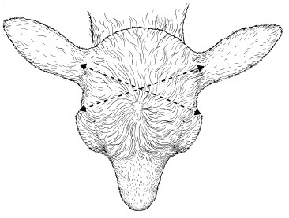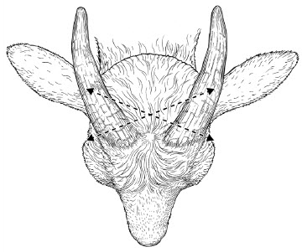
Proper site in horned goats or sheep is behind the poll as shown.

Again, NOT BETWEEN THE EYES! Slightly behind the poll or on the top of the head.
Swine
For swine, there are three possible sites: frontal, temporal and from behind the ear toward the opposite eye. Recommended placement of the penetrating captive bolt or device for use of the frontal site is in the center of the forehead slightly above a line drawn between the eyes. The bolt or free bullet should be directed toward the spinal canal. Proper placement and aim of the euthanasia device is particularly important since the brain is relatively small and well protected by sinuses. Alternative sites for gunshot (only) are the temporal region or from behind the ear directed diagonally toward the opposite eye. As advised anytime euthanasia is performed with a firearm, one must be careful of the location of on-lookers. By-standers should always be positioned behind the person using the device.
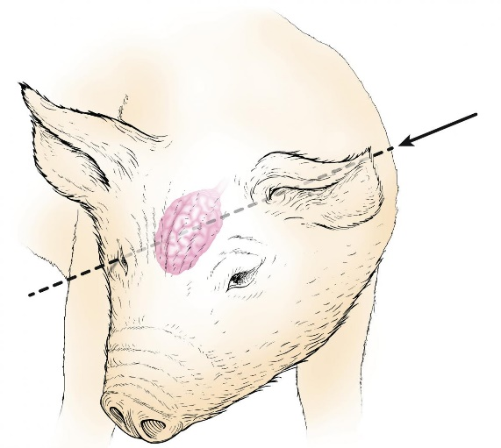
In swine there are 3 possible sites: frontal, temporal or from behind the ear toward the opposite eye
Horses
Horses may be euthanized by gunshot or penetrating captive bolt. As described previously, use of the captive bolt requires good restraint so that the device may be held in close contact with the skull when fired. The site for entry of the projectile is described as being on the intersection of two diagonal lines each running from the outer corner of the eye to the top of the opposite ear (note diagram). An alternative means of finding the appropriate site is to direct the bolt or free bullet 1-2 inches (2.5-5 cm) above the intersection of 2 lines each drawn from the top of the eye to the base of the opposite ear. NOT BETWEEN THE EYES, but on the intersection of 2 lines each drawn from the outer corner of the eye to the top of the opposite ear.
Deer
The proper site in deer is similar to that in cattle. The methods described for emergency euthanasia of deer are similar to those described previously for cattle and small ruminants. Recommended positions and direction for firing of a penetrating captive bolt or gunshot in deer are as shown.
Since deer requiring euthanasia may be encountered on farm or roadside conditions, it is important to consider the natural instincts of fear and anxiety of a farm-raised verses wild animal. Approaching an injured wild deer will likely increase its distress causing it to attempt to flee which may only compound its misery. In general, whenever wildlife are involved in highway accidents, the best advice is to contact the appropriate state wildlife authorities. Their personnel are properly trained to handle these emergencies.
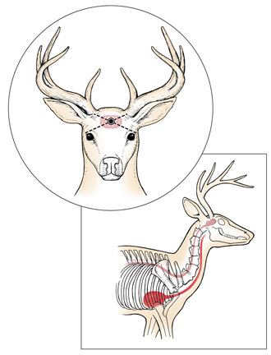
6. Second Euthanasia Method - Pithing
Pithing is a technique designed to cause death by increasing the destruction of brain tissue. It is performed by inserting a pithing rod or tool through the entry site produced in the skull by the penetrating captive bolt stunner. The operator manipulates the pithing tool to destroy both brain stem and spinal cord tissue which ensures death. It is required that pithing be performed on every animal that is euthanized with the captive bolt device prior to any other procedure. required every time the captive bolt device is used.
7. Confirmation of Death
Regardless of the method of euthanasia used, death must be confirmed before disposal of the animal. The following should be used to evaluate consciousness or confirm death:
Lack of a heartbeat
Lack of respiration
Lack of corneal reflex
Presence of rigor mortis

The presence of a heart beat can best be determined with a stethoscope placed under the left elbow. Please note that a pulse is usually not palpable under such circumstances and should not be used to confirm death. Movement of the chest indicates respiration but respiration rates may be very erratic or absent in unconscious animals. Therefore, one must be cautious in the interpretation of respiration for confirmation of death. One may test for evidence of a corneal reflex by touching the surface of the eyeball. Normal or conscious animals will blink when the eyeball is touched. Absence of a corneal reflex, failure to detect respiration, and absence of a heart beat for a period of more than 5 minutes should be used to confirm death. An alternative is to observe the animal over a period of several hours. Lack of movement, absence of a heartbeat, respiration, or corneal reflex over an extended period of time provides further confirmation of death.

8. Cleaning the Captive Bolt Device After Use
Each time a captive-bolt stunner is used it should be cleaned to prevent corrosion and hardening of carbon deposits. It is essential that the following simple operations are carried out in order to ensure maximum bolt velocity and effective stunning:
- Unscrew the muzzle from the barrel and remove the bolt assembly, i.e. bolt, washers and recuperator sleeves.
- Wipe out the inside of the barrel with a soft, dry cloth and scrub with a wire brush to remove the day’s soft powder and sludge. This is best done while the barrel is still warm and before the powder solidifies.
- Remove the washers and recuperator sleeves from the bolt and remove any carbon using a wire wheel or brush. Once cleaned, wipe the bolt over with a lightly oiled rag.
- Clean any powder and/or sludge from the recuperator sleeves and washers, reassemble them on the bolt in a different order to that in which they were removed, i.e. move former middle sleeves to the ends and former end sleeves to the middle. End sleeves wear the fastest, so rearranging the order minimizes uneven wear. A full set of sleeves should last for approximately 4,000 shots.
- Using the tool provided, remove any carbon deposits from the breech and tap out onto a hard surface, such as a wooden table-top.
- The enlarged diameter inside the barrel at the breech block end (the undercut), must be kept from filling with powder, otherwise bolt return and stunning power will be adversely affected. Therefore, in addition to daily cleaning, the following procedure should be carried out weekly with an undercut cleaning tool which is provided with the stunner:
  - Grip the undercut cleaner vertically in a vice.
  - Slide the barrel down the cleaner until the breach face makes contact.
  - Apply sideways pressure to the barrel, so that the cleaner enters the undercut in the barrel. Maintaining this pressure, rotate the barrel backwards and forwards two or three times. Turn the barrel through 90° and then repeat backwards and forwards movement. Repeat this process until the undercut has been thoroughly cleaned.
- Reassemble the stunner and wipe all metal parts with an oily rag. Wrap the stunner in an oily rag before storage.
9. Training and Certification

- Anyone using the captive bolt device must be trained and certified by Dr. Annie Renzetti or an individual Dr. Renzetti has designated as qualified to certify a user. This training must be completed on at least an annual basis. Dr. Annie Renzetti will maintain a database of trained personnel and conduct regular training sessions.
10. Storage of Captive Bolt Device (Location and Security)
- The captive bolt device will be stored in a safe bolted to the floor in the office of the Dairy on the Newark Farm.
11. Documentation of Use
- A log of use of the device, and cleaning procedures must be maintained.

